**XgBoost:**

*Mixed case (without amino acids):*

Without cong:

Confusion Matrix:

-----------------

True Positives | 48

False Positives | 16

True Negatives | 24

False Negatives | 12

-----------------

Accuracy: 0.7200

Precision: 0.7500

Recall: 0.8000

F1-Score: 0.7742

-----------------

With conf:

Confusion Matrix:

-----------------

True Positives | 49

False Positives | 13

True Negatives | 27

False Negatives | 11

-----------------

Accuracy: 0.7600

Precision: 0.7903

Recall: 0.8167

F1-Score: 0.8033

-----------------

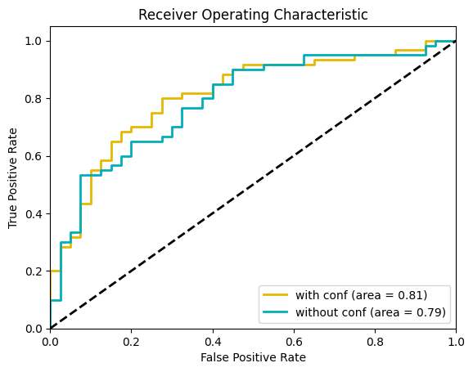

*Mixed case (with amino acids):*

*Without conf:*

*Confusion Matrix:*

*-----------------*

*True Positives | 54*

*False Positives | 10*

*True Negatives | 30*

*False Negatives | 6*

*-----------------*

*Accuracy: 0.8400*

*Precision: 0.8438*

*Recall: 0.9000*

*F1-Score: 0.8710*

*-----------------*

*With conf:*

*Confusion Matrix:*

*-----------------*

*True Positives | 55*

*False Positives | 7*

*True Negatives | 33*

*False Negatives | 5*

*-----------------*

*Accuracy: 0.8800*

*Precision: 0.8871*

*Recall: 0.9167*

*F1-Score: 0.9016*

*-----------------*

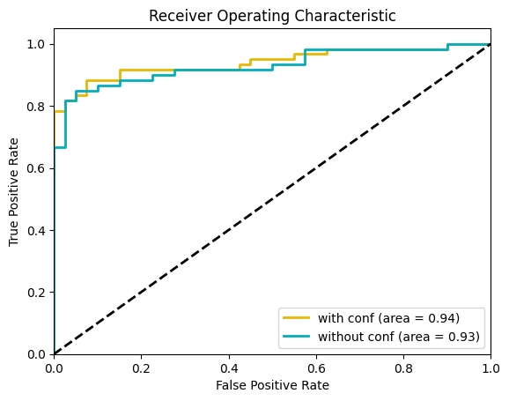

**Using CNN:**

*Mixed case (without amino acids):*

*Without conf:*

Confusion Matrix:

-----------------

True Positives | 44

False Positives | 15

True Negatives | 25

False Negatives | 16

-----------------

Accuracy: 0.6900

Precision: 0.7458

Recall: 0.7333

F1-Score: 0.7395

-----------------

With conf:

Confusion Matrix:

-----------------

True Positives | 46

False Positives | 5

True Negatives | 35

False Negatives | 14

-----------------

Accuracy: 0.8100

Precision: 0.9020

Recall: 0.7667

F1-Score: 0.8288

-----------------

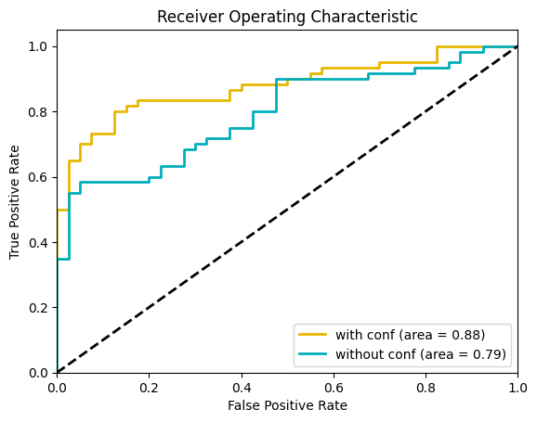

*Mixed case (with amino acids):*

*Without conf:*

*Confusion Matrix:*

*-----------------*

*True Positives | 52*

*False Positives | 3*

*True Negatives | 37*

*False Negatives | 8*

*-----------------*

*Accuracy: 0.8900*

*Precision: 0.9455*

*Recall: 0.8667*

*F1-Score: 0.9043*

*-----------------*

*With conf:*

*Confusion Matrix:*

*-----------------*

*True Positives | 53*

*False Positives | 0*

*True Negatives | 40*

*False Negatives | 7*

*-----------------*

*Accuracy: 0.9300*

*Precision: 1.0000*

*Recall: 0.8833*

*F1-Score: 0.9381*

*-----------------*

